23.online shopping management system

Use case diagram

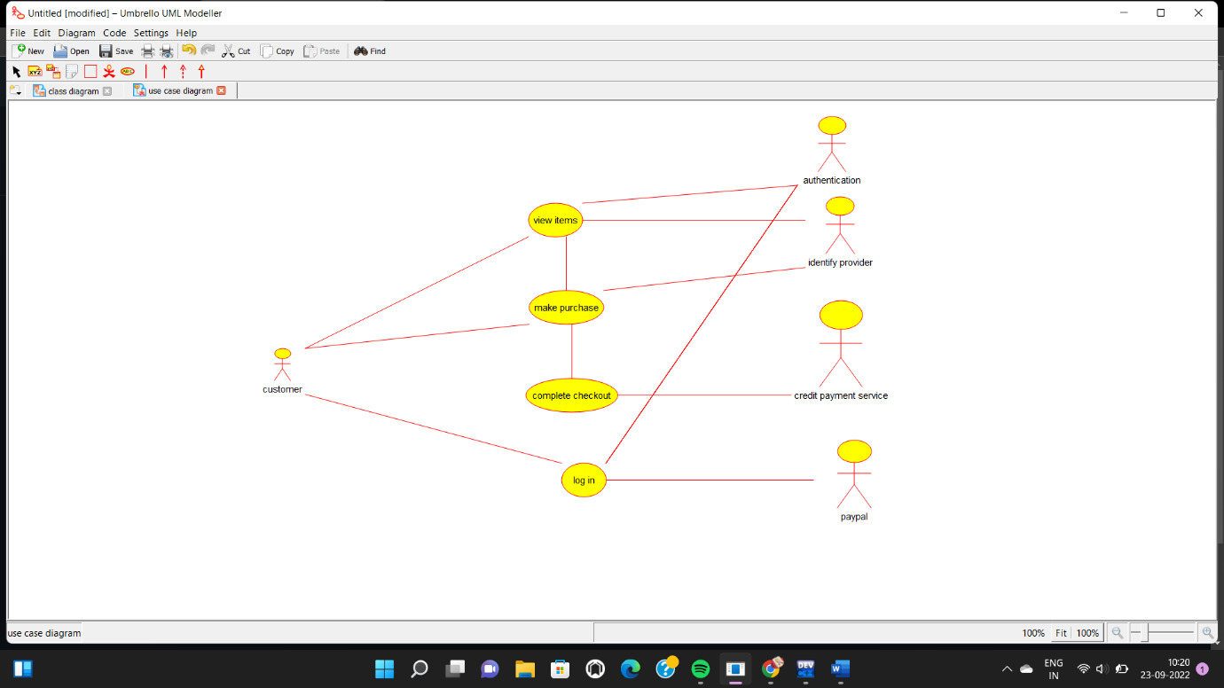

Class diagram

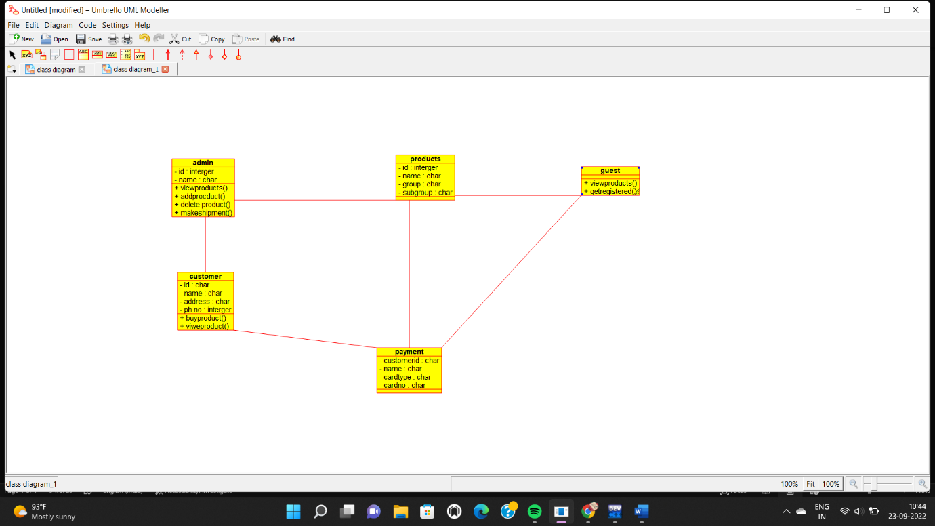

Source code

#include "admin.h"

// Constructors/Destructors

//

admin::admin () {

initAttributes();

}

admin::~admin () { }

//

// Methods

//

// Accessor methods

//

// Other methods

//

void admin::initAttributes () {

}